Project Details | Information
Prepared By | Akshay Ashok Naralakar
Domain | Data Analytics
Project | Week 1 Corporate Project
Tools & Technologies | Python, Pandas, NumPy, Matplotlib & Microsoft Excel
Data Period | January 2025 – August 2026
Retail Sales Data Analysis & Business Performance Report

1. Project Overview
This project focuses on analyzing retail sales data to understand sales and business performance. The analysis covers revenue, profit, products, categories, regions, cities, customers, sales channels, and monthly trends.

The project follows a complete data analytics workflow:
Raw Data → Data Cleaning → Analysis → Visualization → Business Insights → Dashboard

2. Project Objective

- Clean and prepare the sales data.
- Analyze sales and profit performance.
- Identify top-performing products and categories.
- Analyze regional, city, customer and sales channel performance.
- Analyze monthly sales and profit trends.
- Create visualizations and an Excel dashboard.

3. Data Understanding & Cleaning
- Initial Records: 2,000
- Columns: 16
- Data Period: January 2025 – August 2026
- Handled missing values and duplicates.
- Removed invalid quantities and prices.
- Converted dates into the correct format.
- Validated Revenue and Profit calculations.
- Checked customer data consistency.
- Final Records: 1,985

4. Key Performance Indicators
KPI | Result
Total Revenue | ₹7,394,263.75
Total Profit | ₹2,584,863.75
Total Orders | 1,985
Units Sold | 4,171
Average Order Value | ₹3,725.07
Profit Margin | 34.96%

5. Business Insights
5.1 Profit Margin by Category
Fashion recorded the highest profit margin at 40.02%, while Grocery had the lowest margin at 26.87%.
Graph: Profit Margin by Category
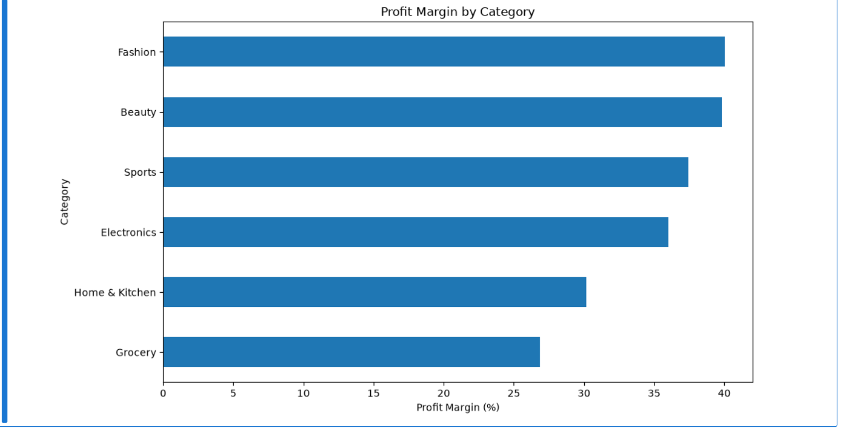

5.2 Regional Performance
The West region generated the highest revenue of ₹2,473,085.50, contributing the largest regional revenue.
Graph: Revenue by Region

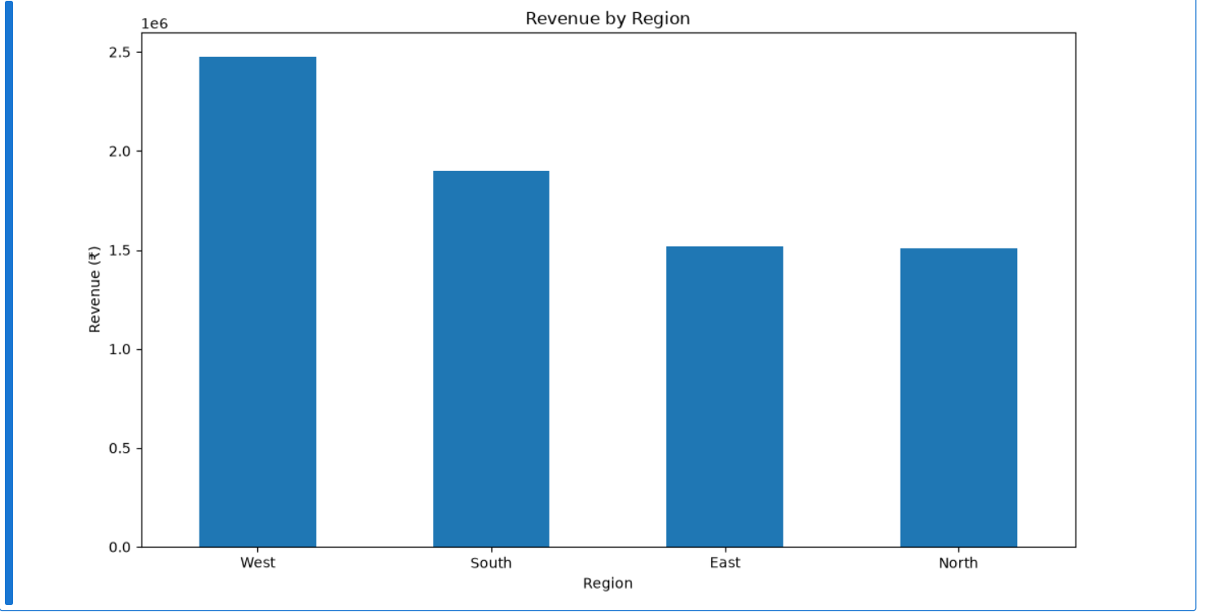

5.3 City Performance
Pune recorded the highest city-level revenue among the analyzed cities.
Graph: Top 10 Cities by Revenue

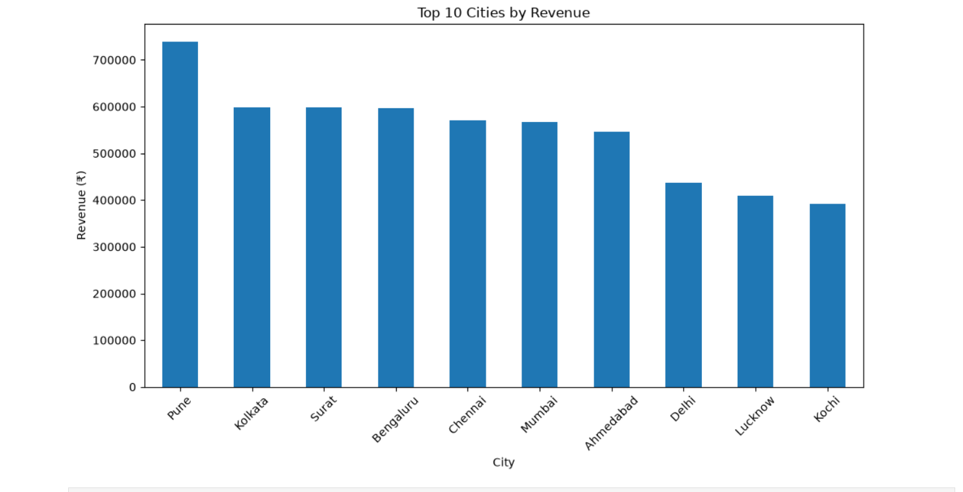

5.4 Product Performance
Air Fryer was the highest revenue-generating product with revenue of ₹822,375.45.
Graph: Top 10 Products by Revenue

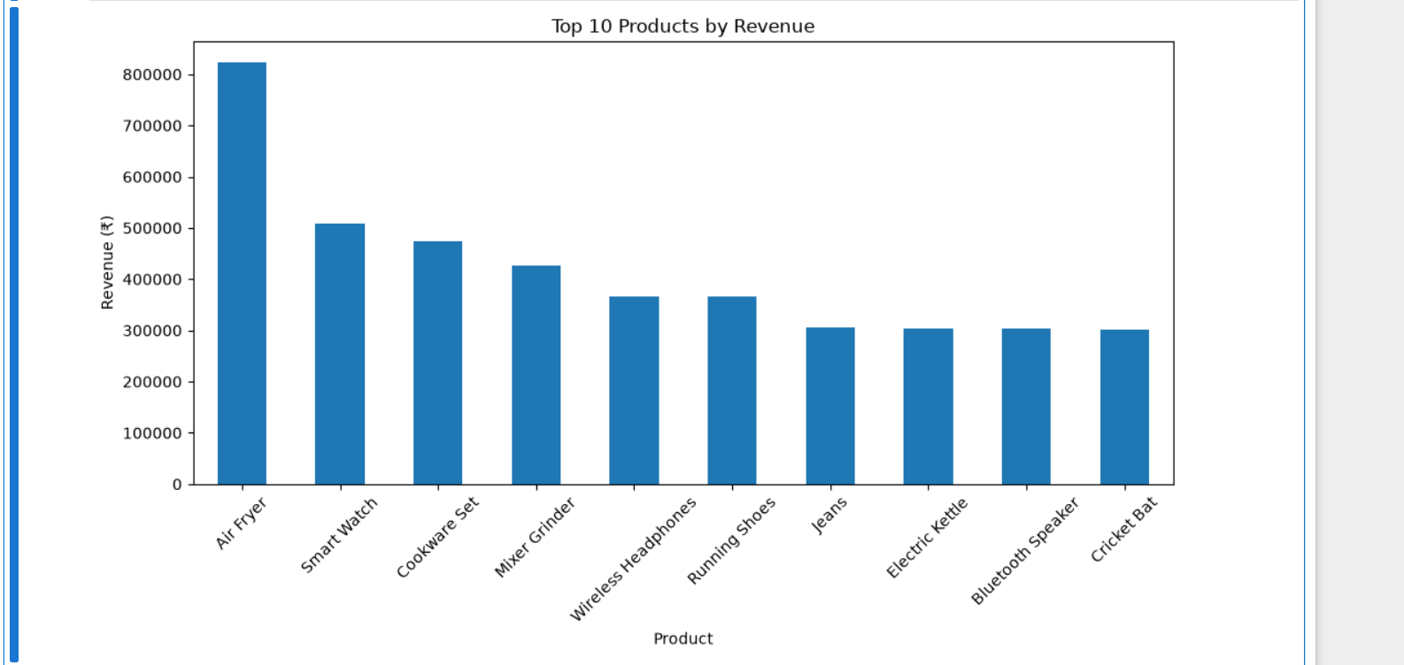

5.5 Product Performance
Product performance was analyzed based on both revenue and profit to identify the major contributing products.
Air Fryer was the highest revenue-generating product with revenue of ₹822,375.45.
Graph: Top 10 Products by Revenue
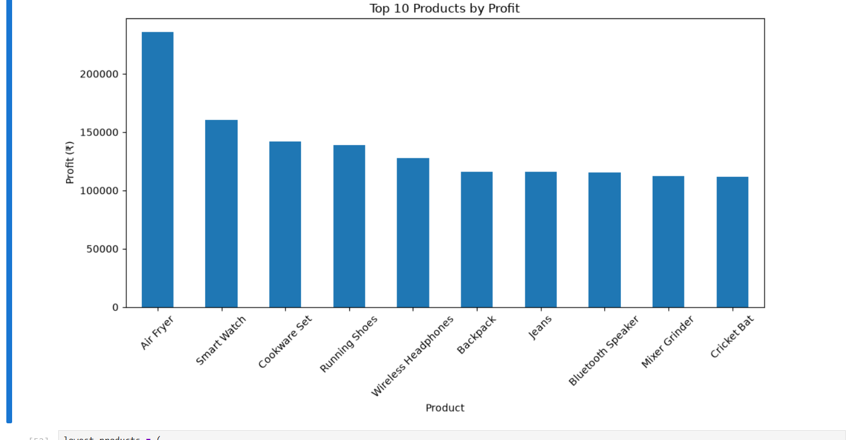

5.6 Monthly Performance
Monthly revenue varied during the analysis period. April 2025 recorded the highest monthly revenue of ₹452,265.30, while February 2026 recorded the lowest at ₹242,841.50.
Graphs: Monthly Revenue Trend & Monthly Profit Trend
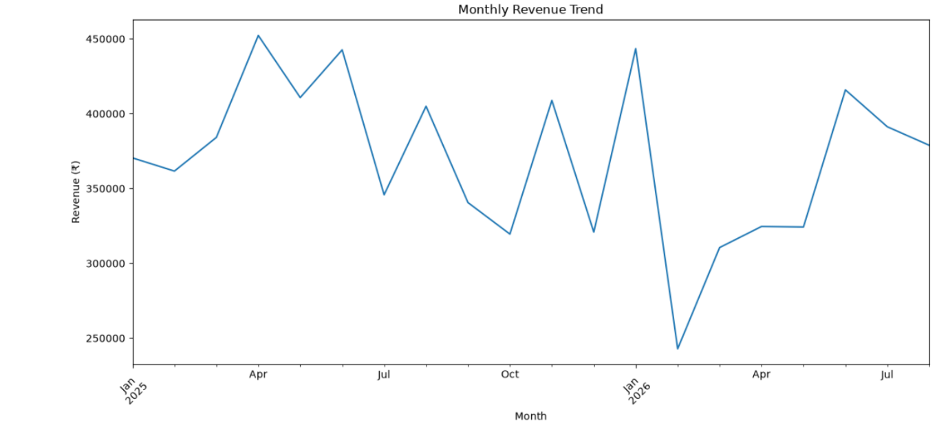

5.7 Monthly Performance
Monthly revenue and profit were analyzed to understand the business performance over time. The trends show variation in both revenue and profit across different months.
Highest Monthly Revenue: April 2025 – ₹452,265.30
Lowest Monthly Revenue: February 2026 – ₹242,841.50
Graph: Monthly Revenue Trend

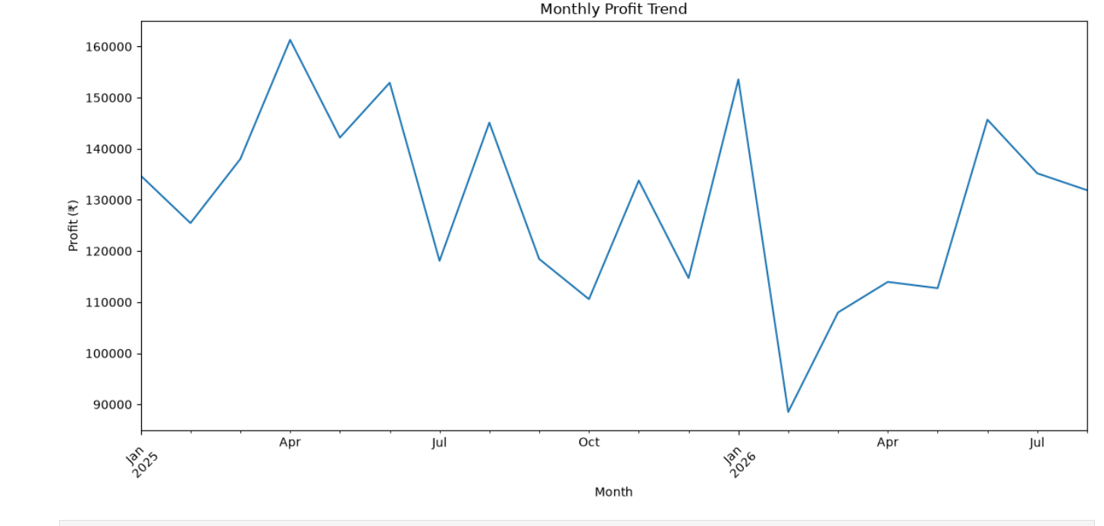

5.8 Monthly Orders
Monthly order volume was analyzed to understand how the number of orders changed over the study period. The analysis shows variation in order volume across different months, helping identify periods of higher and lower customer activity.
Graph: Monthly Orders
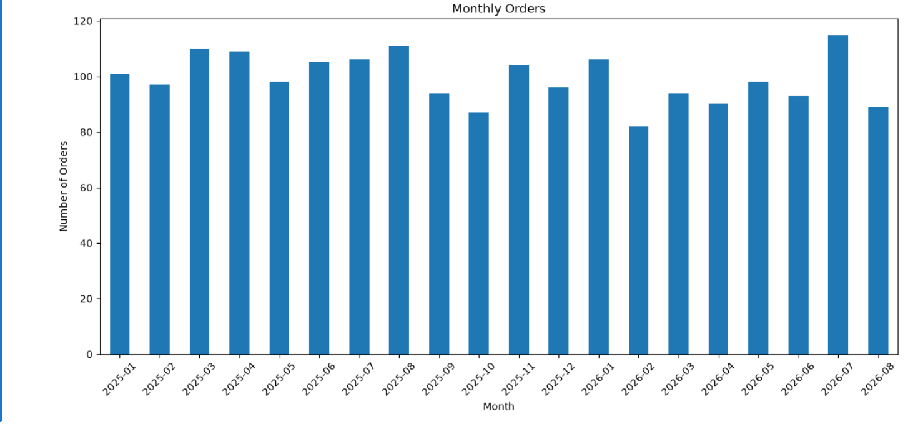

5.9 Sales Channel Performance
Sales performance was analyzed across Online and Offline channels to understand where orders and revenue were generated.
- Online: 1,257 orders, Revenue ₹46,71,139.55
- Offline: 728 orders, Revenue ₹27,23,124.20
Online sales generated higher order volume and revenue during the analysis period.
Graph: Orders by Sales Channel
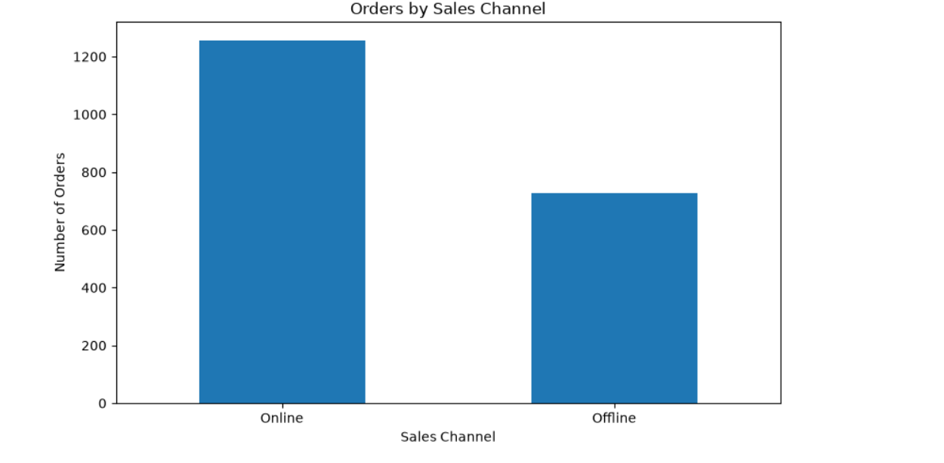

6. Key Performance Summary
- Home & Kitchen leads category revenue.
- Fashion has the highest profit margin.
- Grocery has the lowest profit margin.
- West leads regional revenue.
- Pune leads city revenue.
- Air Fryer leads product revenue.
- Online is the larger sales channel.
- April 2025 recorded the highest monthly revenue.
- February 2026 recorded the lowest monthly revenue.
- The business achieved an overall 34.96% profit margin.

7. Tools & Technologies Used
Python | Pandas | NumPy | Matplotlib | Microsoft Excel | PivotTables | Excel Dashboard

8. Final Deliverables
- Raw Dataset
- Cleaned Dataset
- Python Notebook / .py File
- Excel Analysis
- Excel Dashboard
- Business Insights Report
- README / Documentation

9. Project Workflow
Raw Data → Cleaning → Analysis → Visualization → Business Insights → Excel Dashboard → Final Report

10. Conclusion
The project transformed raw retail transaction data into a cleaned dataset, analytical results, visualizations and an Excel dashboard.
The analysis provides a clear view of sales, profit, products, categories, regions, cities, customers, sales channels and monthly performance, demonstrating the complete data analyst workflow from raw data to business insights.

